Антон Крамер, 26-я когорта, 4-й спринт

# **Консоль**

## Задание 1

Команда или последовательность команд, которой удалось получить нужные логи:

**grep -R "^233.201.*" ~/logs/2019/12**

Логи:

**/home/morty/logs/2019/12/apache_2019-12-18.txt:233.201.188.154 - - [18/12/2019:21:46:01 +0000] "DELETE /events HTTP/1.1" 403 3971**

**/home/morty/logs/2019/12/apache_2019-12-21.txt:233.201.182.9 - - [21/12/2019:21:56:20 +0000] "PATCH /users HTTP/1.1" 400 4118**

## Задание 2

Команды, которые создают директории bug1 и events:

**~$ mkdir bug1**

**~$ mkdir bug1/events**

Команда, которой выбираешь запросы за указанный период. Это те запросы, которыми ты отбираешь логи в файл main.txt:  
**~$ grep "3./12/2019:21:3.:.." ~/logs/2019/12/apache_2019-12-3*.txt > ~/bug1/main.txt**

Команды, которыми ты кладёшь логи в файлы 400.txt и 500.txt из main.txt:  
**~$ grep "400" ~/bug1/main.txt > ~/bug1/events/400.txt**

**~$ grep "500" ~/bug1/main.txt > ~/bug1/events/500.txt**

400.txt

**morty@8aac4c1694fd:~/logs/2019/12$ cat ~/bug1/events/400.txt**

**/home/morty/logs/2019/12/apache_2019-12-30.txt:80.57.170.51 - - [30/12/2019:21:35:12 +0000] "DELETE /users HTTP/1.1" 400 3623**

**/home/morty/logs/2019/12/apache_2019-12-30.txt:204.235.176.118 - - [30/12/2019:21:35:13 +0000] "POST /users HTTP/1.1" 400 4704**

**/home/morty/logs/2019/12/apache_2019-12-30.txt:82.95.203.67 - - [30/12/2019:21:35:19 +0000] "DELETE /lists HTTP/1.1" 400 3737**

**/home/morty/logs/2019/12/apache_2019-12-30.txt:155.242.215.46 - - [30/12/2019:21:35:38 +0000] "POST /playbooks HTTP/1.1" 400 4450**

**/home/morty/logs/2019/12/apache_2019-12-30.txt:189.176.85.0 - - [30/12/2019:21:35:39 +0000] "PATCH /alerts HTTP/1.1" 400 2732**

**/home/morty/logs/2019/12/apache_2019-12-30.txt:13.108.71.71 - - [30/12/2019:21:35:43 +0000] "PATCH /events HTTP/1.1" 400 3410**

**/home/morty/logs/2019/12/apache_2019-12-30.txt:195.213.133.182 - - [30/12/2019:21:35:46 +0000] "PUT /customers HTTP/1.1" 400 3085**

**/home/morty/logs/2019/12/apache_2019-12-30.txt:235.243.133.78 - - [30/12/2019:21:35:47 +0000] "PATCH /customers HTTP/1.1" 400 3264**

**/home/morty/logs/2019/12/apache_2019-12-30.txt:192.57.115.49 - - [30/12/2019:21:35:55 +0000] "POST /parsers HTTP/1.1" 400 2457**

**/home/morty/logs/2019/12/apache_2019-12-30.txt:71.0.49.244 - - [30/12/2019:21:35:55 +0000] "PUT /collectors HTTP/1.1" 400 2785**

**/home/morty/logs/2019/12/apache_2019-12-30.txt:224.159.206.126 - - [30/12/2019:21:36:02 +0000] "DELETE /customers HTTP/1.1" 400 4569**

**/home/morty/logs/2019/12/apache_2019-12-30.txt:131.35.106.246 - - [30/12/2019:21:36:04 +0000] "DELETE /lists HTTP/1.1" 400 2578**

**/home/morty/logs/2019/12/apache_2019-12-30.txt:216.24.42.208 - - [30/12/2019:21:36:06 +0000] "GET /parsers HTTP/1.1" 400 4597**

**/home/morty/logs/2019/12/apache_2019-12-30.txt:123.53.150.160 - - [30/12/2019:21:37:19 +0000] "PATCH /events HTTP/1.1" 400 4379**

**/home/morty/logs/2019/12/apache_2019-12-30.txt:61.129.127.103 - - [30/12/2019:21:37:32 +0000] "GET /lists HTTP/1.1" 400 2575**

**/home/morty/logs/2019/12/apache_2019-12-30.txt:90.216.4.78 - - [30/12/2019:21:37:34 +0000] "PATCH /lists HTTP/1.1" 400 3899**

**/home/morty/logs/2019/12/apache_2019-12-30.txt:204.250.214.208 - - [30/12/2019:21:37:36 +0000] "PATCH /parsers HTTP/1.1" 400 4742**

**/home/morty/logs/2019/12/apache_2019-12-30.txt:79.214.240.98 - - [30/12/2019:21:37:37 +0000] "POST /fieldsets HTTP/1.1" 400 4441**

**/home/morty/logs/2019/12/apache_2019-12-30.txt:65.47.42.12 - - [30/12/2019:21:37:39 +0000] "PATCH /customers HTTP/1.1" 400 2500**

**/home/morty/logs/2019/12/apache_2019-12-30.txt:251.118.141.34 - - [30/12/2019:21:37:41 +0000] "POST /customers HTTP/1.1" 400 3519**

**/home/morty/logs/2019/12/apache_2019-12-30.txt:205.20.166.196 - - [30/12/2019:21:37:51 +0000] "POST /users HTTP/1.1" 400 4032**

**/home/morty/logs/2019/12/apache_2019-12-30.txt:156.217.3.46 - - [30/12/2019:21:37:52 +0000] "PATCH /parsers HTTP/1.1" 400 2020**

**/home/morty/logs/2019/12/apache_2019-12-30.txt:48.240.198.167 - - [30/12/2019:21:37:57 +0000] "PATCH /playbooks HTTP/1.1" 400 4100**

**/home/morty/logs/2019/12/apache_2019-12-30.txt:101.255.159.211 - - [30/12/2019:21:37:59 +0000] "GET /auth HTTP/1.1" 400 2324**

**/home/morty/logs/2019/12/apache_2019-12-30.txt:80.76.98.203 - - [30/12/2019:21:38:00 +0000] "POST /playbooks HTTP/1.1" 400 3045**

**/home/morty/logs/2019/12/apache_2019-12-30.txt:85.64.63.255 - - [30/12/2019:21:38:13 +0000] "PATCH /collectors HTTP/1.1" 400 2291**

**/home/morty/logs/2019/12/apache_2019-12-30.txt:184.79.247.161 - - [30/12/2019:21:38:13 +0000] "PUT /alerts HTTP/1.1" 400 3557**

**/home/morty/logs/2019/12/apache_2019-12-30.txt:93.2.134.22 - - [30/12/2019:21:39:39 +0000] "DELETE /alerts HTTP/1.1" 400 3701**

**/home/morty/logs/2019/12/apache_2019-12-31.txt:86.34.86.182 - - [31/12/2019:21:35:10 +0000] "POST /auth HTTP/1.1" 400 3626**

**/home/morty/logs/2019/12/apache_2019-12-31.txt:167.37.16.117 - - [31/12/2019:21:35:17 +0000] "PATCH /customers HTTP/1.1" 400 3294**

**/home/morty/logs/2019/12/apache_2019-12-31.txt:199.128.92.19 - - [31/12/2019:21:35:43 +0000] "PUT /users HTTP/1.1" 400 4180**

**/home/morty/logs/2019/12/apache_2019-12-31.txt:162.152.99.143 - - [31/12/2019:21:35:59 +0000] "PUT /users HTTP/1.1" 400 4606**

**/home/morty/logs/2019/12/apache_2019-12-31.txt:83.115.59.224 - - [31/12/2019:21:37:26 +0000] "GET /alerts HTTP/1.1" 400 3489**

**/home/morty/logs/2019/12/apache_2019-12-31.txt:194.10.97.226 - - [31/12/2019:21:37:31 +0000] "DELETE /lists HTTP/1.1" 400 2447**

**/home/morty/logs/2019/12/apache_2019-12-31.txt:180.99.214.40 - - [31/12/2019:21:37:44 +0000] "DELETE /alerts HTTP/1.1" 400 2077**

**/home/morty/logs/2019/12/apache_2019-12-31.txt:154.152.205.4 - - [31/12/2019:21:37:50 +0000] "GET /playbooks HTTP/1.1" 400 3324**

**/home/morty/logs/2019/12/apache_2019-12-31.txt:197.82.125.54 - - [31/12/2019:21:37:52 +0000] "PUT /fieldsets HTTP/1.1" 400 4365**

**/home/morty/logs/2019/12/apache_2019-12-31.txt:115.89.87.219 - - [31/12/2019:21:38:06 +0000] "PUT /playbooks HTTP/1.1" 400 2589**

**/home/morty/logs/2019/12/apache_2019-12-31.txt:100.77.15.14 - - [31/12/2019:21:38:07 +0000] "GET /fieldsets HTTP/1.1" 400 4911**

**/home/morty/logs/2019/12/apache_2019-12-31.txt:22.33.159.242 - - [31/12/2019:21:38:07 +0000] "GET /playbooks HTTP/1.1" 400 3955**

**/home/morty/logs/2019/12/apache_2019-12-31.txt:149.148.229.11 - - [31/12/2019:21:39:16 +0000] "GET /users HTTP/1.1" 400 2071**

**/home/morty/logs/2019/12/apache_2019-12-31.txt:236.107.64.192 - - [31/12/2019:21:39:17 +0000] "PATCH /users HTTP/1.1" 400 2791**

**/home/morty/logs/2019/12/apache_2019-12-31.txt:24.156.105.39 - - [31/12/2019:21:39:23 +0000] "GET /lists HTTP/1.1" 400 2902**

**/home/morty/logs/2019/12/apache_2019-12-31.txt:193.50.164.254 - - [31/12/2019:21:39:23 +0000] "PUT /playbooks HTTP/1.1" 400 3296**

**/home/morty/logs/2019/12/apache_2019-12-31.txt:18.123.104.91 - - [31/12/2019:21:39:52 +0000] "GET /collectors HTTP/1.1" 400 4372**

**/home/morty/logs/2019/12/apache_2019-12-31.txt:234.218.148.4 - - [31/12/2019:21:39:54 +0000] "PUT /users HTTP/1.1" 400 2509**

500.txt.

**morty@8aac4c1694fd:~/logs/2019/12$ cat ~/bug1/events/500.txt**

**/home/morty/logs/2019/12/apache_2019-12-30.txt:64.250.112.189 - - [30/12/2019:21:35:13 +0000] "PUT /parsers HTTP/1.1" 500 4639**

**/home/morty/logs/2019/12/apache_2019-12-30.txt:193.253.101.180 - - [30/12/2019:21:35:31 +0000] "PATCH /alerts HTTP/1.1" 500 2944**

**/home/morty/logs/2019/12/apache_2019-12-30.txt:197.106.117.194 - - [30/12/2019:21:35:31 +0000] "PATCH /parsers HTTP/1.1" 500 3519**

**/home/morty/logs/2019/12/apache_2019-12-30.txt:247.124.71.67 - - [30/12/2019:21:35:45 +0000] "PUT /alerts HTTP/1.1" 500 2746**

**/home/morty/logs/2019/12/apache_2019-12-30.txt:62.88.204.119 - - [30/12/2019:21:35:51 +0000] "PUT /auth HTTP/1.1" 500 2666**

**/home/morty/logs/2019/12/apache_2019-12-30.txt:125.156.142.26 - - [30/12/2019:21:36:01 +0000] "PATCH /events HTTP/1.1" 500 3460**

**/home/morty/logs/2019/12/apache_2019-12-30.txt:144.170.212.70 - - [30/12/2019:21:36:04 +0000] "DELETE /parsers HTTP/1.1" 500 2599**

**/home/morty/logs/2019/12/apache_2019-12-30.txt:59.39.200.252 - - [30/12/2019:21:36:05 +0000] "GET /alerts HTTP/1.1" 500 2650**

**/home/morty/logs/2019/12/apache_2019-12-30.txt:150.136.200.100 - - [30/12/2019:21:37:24 +0000] "POST /lists HTTP/1.1" 500 2684**

**/home/morty/logs/2019/12/apache_2019-12-30.txt:84.81.25.45 - - [30/12/2019:21:37:25 +0000] "POST /auth HTTP/1.1" 500 2052**

**/home/morty/logs/2019/12/apache_2019-12-30.txt:30.222.160.141 - - [30/12/2019:21:37:30 +0000] "PATCH /parsers HTTP/1.1" 500 2017**

**/home/morty/logs/2019/12/apache_2019-12-30.txt:117.87.158.36 - - [30/12/2019:21:37:34 +0000] "POST /fieldsets HTTP/1.1" 500 4056**

**/home/morty/logs/2019/12/apache_2019-12-30.txt:65.47.42.12 - - [30/12/2019:21:37:39 +0000] "PATCH /customers HTTP/1.1" 400 2500**

**/home/morty/logs/2019/12/apache_2019-12-30.txt:212.153.128.212 - - [30/12/2019:21:37:42 +0000] "PUT /fieldsets HTTP/1.1" 500 3259**

**/home/morty/logs/2019/12/apache_2019-12-30.txt:58.188.83.217 - - [30/12/2019:21:37:46 +0000] "POST /playbooks HTTP/1.1" 500 3947**

**/home/morty/logs/2019/12/apache_2019-12-30.txt:193.123.131.146 - - [30/12/2019:21:37:47 +0000] "PUT /lists HTTP/1.1" 500 3902**

**/home/morty/logs/2019/12/apache_2019-12-30.txt:182.7.179.91 - - [30/12/2019:21:37:48 +0000] "GET /users HTTP/1.1" 500 2950**

**/home/morty/logs/2019/12/apache_2019-12-30.txt:10.25.168.164 - - [30/12/2019:21:38:05 +0000] "PATCH /playbooks HTTP/1.1" 500 3858**

**/home/morty/logs/2019/12/apache_2019-12-30.txt:215.201.210.173 - - [30/12/2019:21:38:11 +0000] "PATCH /customers HTTP/1.1" 500 3277**

**/home/morty/logs/2019/12/apache_2019-12-30.txt:179.241.103.167 - - [30/12/2019:21:39:23 +0000] "POST /lists HTTP/1.1" 500 3669**

**/home/morty/logs/2019/12/apache_2019-12-30.txt:147.188.170.252 - - [30/12/2019:21:39:33 +0000] "POST /fieldsets HTTP/1.1" 500 3313**

**/home/morty/logs/2019/12/apache_2019-12-30.txt:1.249.123.189 - - [30/12/2019:21:39:36 +0000] "PATCH /alerts HTTP/1.1" 500 4734**

**/home/morty/logs/2019/12/apache_2019-12-30.txt:124.114.135.105 - - [30/12/2019:21:39:41 +0000] "PATCH /customers HTTP/1.1" 500 3348**

**/home/morty/logs/2019/12/apache_2019-12-30.txt:35.215.100.202 - - [30/12/2019:21:39:43 +0000] "PUT /alerts HTTP/1.1" 500 4345**

**/home/morty/logs/2019/12/apache_2019-12-30.txt:86.222.23.128 - - [30/12/2019:21:39:44 +0000] "PATCH /alerts HTTP/1.1" 500 2230**

**/home/morty/logs/2019/12/apache_2019-12-30.txt:20.161.75.95 - - [30/12/2019:21:39:48 +0000] "DELETE /users HTTP/1.1" 500 2412**

**/home/morty/logs/2019/12/apache_2019-12-30.txt:196.18.151.117 - - [30/12/2019:21:39:55 +0000] "PUT /events HTTP/1.1" 500 4439**

**/home/morty/logs/2019/12/apache_2019-12-30.txt:77.101.138.151 - - [30/12/2019:21:39:57 +0000] "PUT /lists HTTP/1.1" 500 2194**

**/home/morty/logs/2019/12/apache_2019-12-31.txt:208.205.133.127 - - [31/12/2019:21:35:17 +0000] "DELETE /alerts HTTP/1.1" 500 4561**

**/home/morty/logs/2019/12/apache_2019-12-31.txt:20.145.255.91 - - [31/12/2019:21:35:30 +0000] "GET /parsers HTTP/1.1" 500 3051**

**/home/morty/logs/2019/12/apache_2019-12-31.txt:91.66.134.13 - - [31/12/2019:21:35:53 +0000] "POST /lists HTTP/1.1" 500 3319**

**/home/morty/logs/2019/12/apache_2019-12-31.txt:31.88.211.206 - - [31/12/2019:21:35:57 +0000] "DELETE /events HTTP/1.1" 500 2325**

**/home/morty/logs/2019/12/apache_2019-12-31.txt:171.37.114.114 - - [31/12/2019:21:37:39 +0000] "DELETE /fieldsets HTTP/1.1" 500 3253**

**/home/morty/logs/2019/12/apache_2019-12-31.txt:223.157.242.167 - - [31/12/2019:21:37:59 +0000] "POST /users HTTP/1.1" 500 2283**

**/home/morty/logs/2019/12/apache_2019-12-31.txt:98.181.102.34 - - [31/12/2019:21:38:06 +0000] "PATCH /fieldsets HTTP/1.1" 500 4672**

**/home/morty/logs/2019/12/apache_2019-12-31.txt:254.74.22.79 - - [31/12/2019:21:38:06 +0000] "PUT /lists HTTP/1.1" 500 2259**

**/home/morty/logs/2019/12/apache_2019-12-31.txt:103.46.238.3 - - [31/12/2019:21:38:09 +0000] "PUT /lists HTTP/1.1" 500 3992**

**/home/morty/logs/2019/12/apache_2019-12-31.txt:41.62.205.107 - - [31/12/2019:21:39:20 +0000] "PATCH /alerts HTTP/1.1" 500 3631**

**/home/morty/logs/2019/12/apache_2019-12-31.txt:22.53.105.197 - - [31/12/2019:21:39:31 +0000] "DELETE /collectors HTTP/1.1" 500 4202**

**/home/morty/logs/2019/12/apache_2019-12-31.txt:178.22.133.42 - - [31/12/2019:21:39:43 +0000] "PUT /alerts HTTP/1.1" 500 4648**

**/home/morty/logs/2019/12/apache_2019-12-31.txt:102.247.13.50 - - [31/12/2019:21:39:55 +0000] "PATCH /auth HTTP/1.1" 500 3736**

## 

# **База данных**

## Задание 1

Число автомобилей:  
 cnt

------------

**5529**

Запрос, которым тебе удалось решить задачу.  
**morty=# \c chicago_taxi**

**chicago_taxi=# SELECT COUNT(*) AS cnt FROM cabs;**

## Задание 2

Список компаний с числом автомобилей меньше 100.

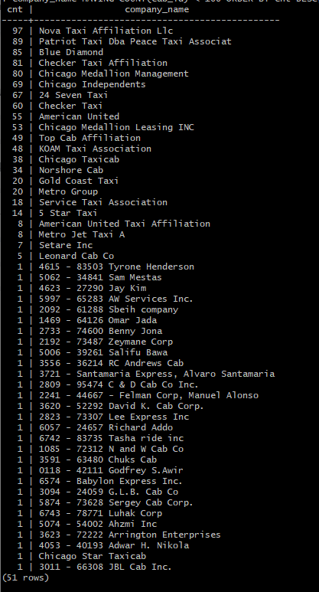

Запрос, которым тебе удалось решить задачу.

**chicago_taxi=# SELECT COUNT(cab_id) AS cnt, company_name AS company_name FROM cabs GROUP BY company_name HAVING COUNT(cab_id) < 100 ORDER BY cnt DESC;**

## Задание 3

Таблица с данными за указанный период.

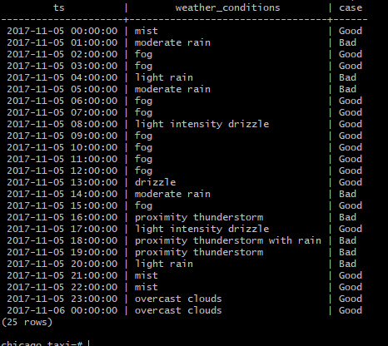

Запрос, которым удалось решить задачу.

**chicago_taxi=# SELECT ts AS ts, description AS weather_conditions, CASE WHEN description LIKE '%rain%' OR description LIKE '%storm%' THEN 'Bad' ELSE 'Good' END FROM weather_records WHERE ts >= '2017-11-05 00:00' AND ts <= '2017-11-06 00:00';**

## Задание 4

Таблица с данными за указанный период.

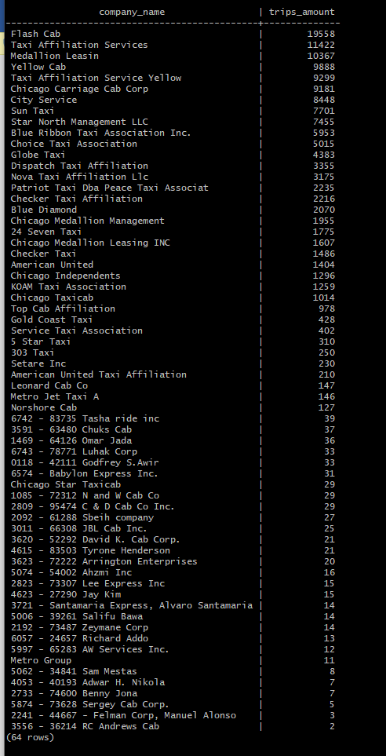

Запрос, которым удалось решить задачу.

**chicago_taxi=# SELECT cabs.company_name AS company_name, COUNT(trips.cab_id) AS trips_amount FROM trips INNER JOIN cabs ON cabs.cab_id = trips.cab_id WHERE start_ts >= '2017-11-15 00:00' AND start_ts <= '2017-11-16 23:59' GROUP BY company_name ORDER BY trips_amount DESC;**